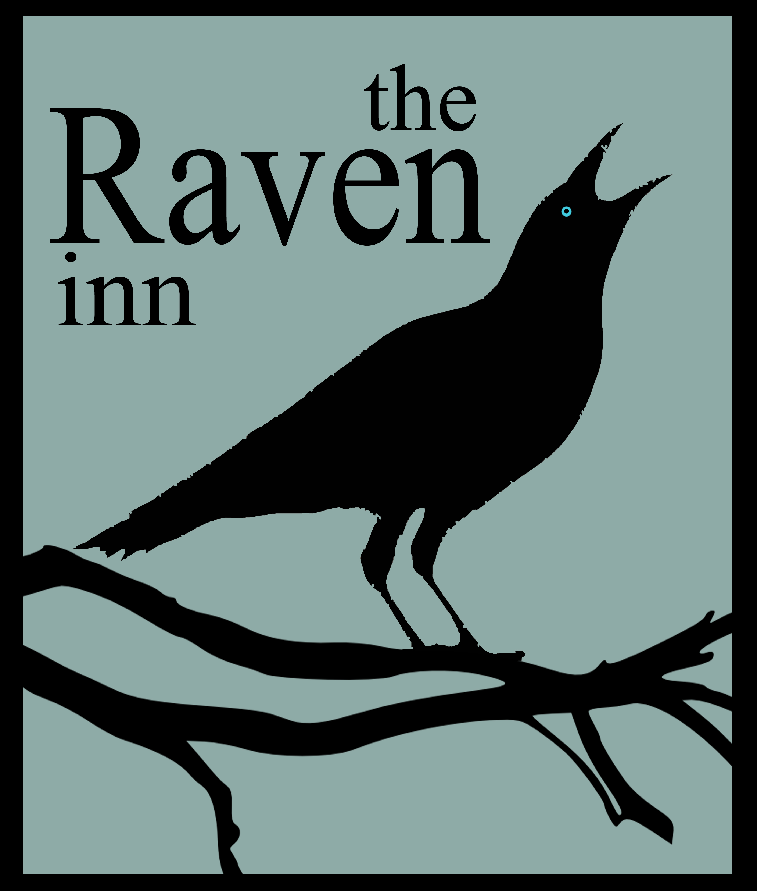
PLEASE ORDER AT THE BAR

er at the bar

TO KEEP YOU GOING……

Mixed olives £3.00
Crusty bread- olive oil - balsamic vinegar £3.50
With olives £5.50
Garlic Bread £3.95 with cheese £4.95

TO START

(V) Homemade Soup of the Day
Served with fresh bread £5.00
Chilli Chicken Kebabs
Spicy chicken breast kebabs with an oriental slaw £6.10
Prawn & Crayfish Cocktail
With paprika croutons, Marie Rose sauce, baby gem lettuce, cherry tomatoes and cucumber £6.50
(V) Creamy Curried Mushrooms
Served in a crisp poppadum basket £5.25
Crispy Breaded Whitebait
Served with homemade tartare sauce and bread & butter £5.95
(V) Asparagus and Ricotta Tortelloni
With a rich red wine and tomato sauce and dressed leaves £5.95
Salmon & Smoked Haddock Fishcake
With a tomato & spring onion salad, tarragon and Dijon mayo £6.25
Pork Terrine
Served with homemade piccalilli, beetroot salad and toast £6.25

FISH

Pan Fried Tuna Steak
With chargrilled aubergine and pepper, served with herb oil and crushed potatoes £11.95
Beer Battered Haddock
Served with mushy peas, tartare sauce and homemade chips £12.50
Salmon & Smoked Haddock Fishcake
With a tomato & spring onion salad, and tarragon & Dijon mayonnaise £13.50

CHEF’S SPECIALS

Oven Roasted Welsh Lamb Rump
With Moroccan couscous, mange tout and feta & garlic yoghurt £15.95
Locally Made Faggots in Onion Gravy
Served with mashed potato and a choice of peas or spiced red cabbage £10.50 (small £8.50)
Pork & Leek Sausages
Three local pork & leek Sausages braised in cider, sage & apple gravy, served with creamy mashed potato and a choice of peas or spiced red cabbage £10.50 (small £8.50)
Pie of the Day - See Blackboard
Topped with a puff pastry pie lid and served with homemade chips or mash, and peas £13.95 (it’s BIG) £10.00 (small)
Curry of the Day - See Blackboard
With chicken £11.50 or vegetables £10.50
With King Prawns £12.50
½ rice ½ chips add £1.50
Crispy Oven Baked Duck Leg
With pickled walnut and warm potato and rocket salad £8.95
Pan Roasted Chicken Supreme
Served with a sundried tomato & pinenuts polenta with a cream of mushroom sauce and vegetables £13.50

VEGETARIAN

(V) Asparagus and Ricotta Tortelloni
With a rich red wine and tomato sauce and pesto ciabatta £11.95
(V) Red Onion & Goats’ Cheese Tart
With new potatoes and red pepper sauce £11.95
(V) Veggie Fish & Chips
Halloumi cheese in crispy beer batter served with mushy peas, tartare sauce and hand cut chips £11.00 (small £9.00)
Our food is homemade and cooked to order, so there may be a wait, especially at busy periods. We think our food is worth the wait!

If you have any special dietary requirements or allergies, please speak to any of our team who will be happy to help

GRILLS

Cooked to your liking and served with homemade chips, mushrooms, grilled tomato and garden peas

20oz Rump £27.95
(Served on a chopping board) – good to share or for very, very hungry people!

10oz Rump steak £16.95

8oz Sirloin £17.50

10oz Rib eye £19.45

10oz Gammon Steak (with egg and pineapple) £11.95 (6oz £9.50)

Add Peppercorn, Creamy Mushroom or Blue Cheese Sauce £2.50

BURGERS - £11

Served in a bun with tomato relish, coleslaw, lettuce, tomato, red onion and homemade chips

Homemade ½lb Beefburger (¼ lb 8.50)

Cajun Chicken Breast Burger

(V) Homemade Mushroom & Chickpea Burger
With jalapeno mayonnaise

PIMP YOUR BURGER:
Add bacon; mature welsh cheddar; onion rings; mushrooms; fried egg; pineapple; gherkin or jalapeño peppers for £1 each

Add Shropshire Blue cheese or halloumi for £1.50 each

SIDE ORDERS

Homemade Chips £3.00 Bread basket £2.00
Side Salad £3.00 Coleslaw £1.50
Bowl of onion rings £3.00 Seasonal Vegetables £2.50
Garlic Bread £3.95 Garlic bread with cheese £4.95

SANDWICHES

All served with dressed leaves, coleslaw and homemade tortilla chips or add homemade chips for £1.
Add a mug of soup for £2.50.

Raven Club Sandwich
Chicken mayonnaise, crispy bacon, lettuce and tomatoes in a warm ciabatta £6.25
Pork & Leek Sausages
In a warm ciabatta with caramelised onions and homemade brown sauce £6.75
(V) Brie & Grape Chutney
In a warm ciabatta with rocket leaves £6.50
Tuna Melt
Tuna and spring onion mayonnaise topped with melted cheddar on ciabatta £6.25
(V) Grilled Halloumi Wrap
with pesto mayonnaise and chargrilled Mediterranean vegetables £6.25
Rump Steak Ciabatta
Cooked to your liking and served with Dijon mayonnaise, mushrooms and caramelised onions £8.00
Chargrilled Cajun Chicken Wrap
with sweet chilli mayonnaise and rocket £6.75

It is advisable to book a table in advance.
If you have not reserved a table, please check with the staff where is available to sit and if we can accommodate you, especially during busy periods. Thank you.

LITTLE PERSONS’ MENU

Panda Pops £1
Cherryade, Cola, Lemonade, Orangeade
Dandelion & Burdock

All dishes are £6.00 and come with an ice cream for pudding!

- Soup & bread (£4.00)
- Burger & chips or mash, peas or beans
- Gammon & chips or mash, peas or beans
- Sausage & gravy, mash or chips, peas or beans
- Chicken nuggets & chips or mash, peas or beans
- Tagliatelle Bolognaise with garlic bread
- Tomato, mozzarella and pepperoni ciabatta pizza & chips or mash, peas or beans
- Roast dinner, roast potatoes, peas and gravy (Sundays only)

COFFEE

Tea £2.00
Espresso £1.75
Americano/Cafetiere £2.50
Double Espresso/Cappuccino/Latte £2.75
Hot Chocolate £2.75
with whipped cream and marshmallows £3.50
Baileys hot chocolate £5.00
Mocha (Hot choc with a shot of espresso coffee) £3.50
Peppermint/Earl Grey/Berry/Green/
Chamomile Teas £2.00
Liqueur coffees £5.00

HOMEMADE PUDDINGS

Mixed Berry Eton Mess
Berries mixed with crushed meringue and Chantilly cream served with a fruit coulis £5.95
Vanilla Creme Brulee
Served with a shortbread biscuit and berry compote £5.50
Traditional Crumble
Apple and Summer Berry with crumble topping and warm vanilla custard £5.95
Tangy Lemon Tart
Served with strawberries poached in a red wine and balsamic syrup £5.95
Frangipane
Almond tart with poached pears and an apricot glaze, served with Chantilly cream £5.95
Rich Chocolate Mousse
Served with chocolate ice cream £5.95

Ice Creams –Choose 3 scoops of the following, all served with a homemade shortbread biscuit for £5.00 – Chocolate/ Clotted Cream & Strawberry / White mint & choc chip /Lemon Sorbet / Caramel Crunch / Vanilla

Cheeseboard
A selection of delicious British cheeses – Welsh Mature Cheddar, Shropshire Blue and Pont Gar Brie - served with grapes, biscuits & homemade grape chutney £6.75

